Spectral coherence: EURUSD and USDCAD
Method 21 / daily log returns / Welch magnitude-squared coherence / Alpari D1 full available history

Study setup
Logical pair: EURUSD , USDCAD
Broker symbols: EURUSD_i , USDCAD_i
Snapshot: 2026-11-03_majors_alpari_D1
Timeframe: D1
Matched return window: 1999-01-05 to 2026-11-02 (UTC bar dates)
Matched return count n: 7188
Dropped unfinished last bar dated 2026-11-03 UTC after a tick-volume check against the prior complete day.
Welch: fs=1.0, nperseg=256, noverlap=128, window=hann, detrend=constant
Headline: gamma^2 nearest f=1/5; also 1/21 and 1/63
Complete matched rows (Excel): EURUSD-USDCAD_Spectral_D1.xlsx
Complete matched rows (HTML table): EURUSD-USDCAD_Spectral_D1_data.html

Method carried forward
Magnitude-squared spectral coherence gamma^2(f) measures shared linear power between matched daily log returns of close, ln(close_t / close_t-1), at each frequency f (cycles per day). Quotes are not inverted. Welch settings are frozen: fs=1, nperseg=256, noverlap=128, window=hann, detrend=constant. Headline is gamma^2 at the frequency bin nearest f=1/5 (five-day cycle from the formula sheet). Also reported: gamma^2 nearest f=1/21 and f=1/63, mean gamma^2 over the frequency grid, and phase of the cross-spectrum at the 1/5 bin. Coherence is unsigned (0 to 1); phase carries timing. Same-sample Pearson r is a side check only. This is not causation and not a trading signal.

Results (headline)
gamma^2 near 1/5: 0.169411
bin f (1/5): 0.199219
phase at 1/5 (rad): -2.745905
gamma^2 near 1/21: 0.079752
gamma^2 near 1/63: 0.235771
mean gamma^2: 0.229684
Pearson r: -0.456626

Target-frequency summary
period | target_f | f_bin | gamma2 | phase_rad
5 | 0.2 | 0.19921875 | 0.16941091 | -2.7459051
21 | 0.04761905 | 0.046875 | 0.07975239 | -3.0486831
63 | 0.01587302 | 0.015625 | 0.23577107 | -3.0664465

Conclusion
Headline gamma^2 near f=1/5 for EURUSD and USDCAD: 0.1694 (bin f=0.199219, phase=-2.7459 rad). At ~1/21: 0.0798; at ~1/63: 0.2358. Mean gamma^2 = 0.2297. Pearson r = -0.4566. This is frequency-domain linkage, not a trading signal.

Charts
Daily closes

Daily log returns

Spectral coherence gamma^2(f)
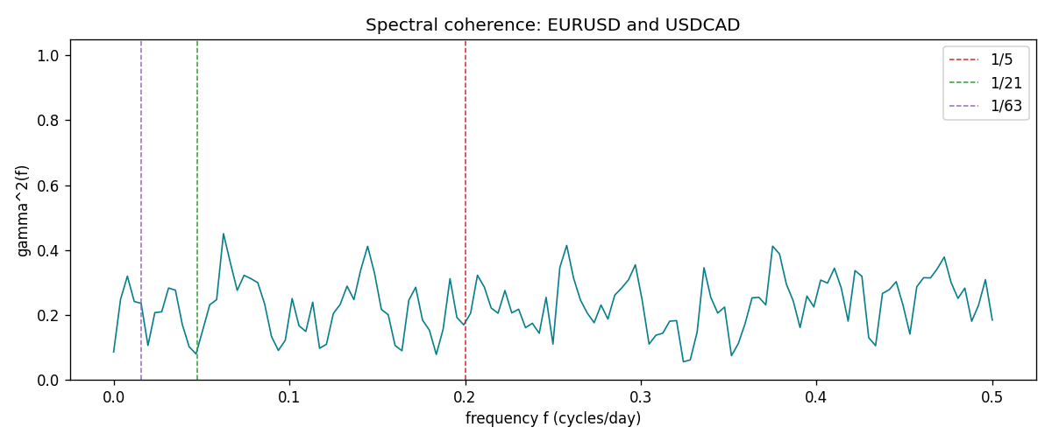

Data report
Matched rows and the coherence sheet are in the sibling Excel workbook named EURUSD-USDCAD_Spectral_D1.xlsx. Embedding all rows as a Word table is impractical; this file holds column summaries and the first and last 15 matched rows.
Columns: time, EURUSD_open, USDCAD_open, EURUSD_high, USDCAD_high, EURUSD_low, USDCAD_low, EURUSD_close, USDCAD_close, EURUSD_tick_volume, USDCAD_tick_volume, EURUSD_spread, USDCAD_spread, EURUSD_real_volume, USDCAD_real_volume, EURUSD_log_return, USDCAD_log_return
Column summaries (matched calculation rows)
column | count | mean | std | min | 25% | 50% | 75% | max
EURUSD_open | 7188 | 1.1814345 | 0.15078289 | 0.8272 | 1.086195 | 1.16617 | 1.2939425 | 1.5995
USDCAD_open | 7188 | 1.2667783 | 0.16890181 | 0.9168 | 1.1183975 | 1.298465 | 1.37211 | 1.6183
EURUSD_high | 7188 | 1.1865652 | 0.15138546 | 0.8326 | 1.0902775 | 1.17128 | 1.2993025 | 1.6038
USDCAD_high | 7188 | 1.2716763 | 0.16885945 | 0.9336 | 1.12285 | 1.30387 | 1.37649 | 1.619
EURUSD_low | 7188 | 1.1764236 | 0.15010221 | 0.8227 | 1.0820675 | 1.16257 | 1.2883725 | 1.5865
USDCAD_low | 7188 | 1.26222 | 0.16893673 | 0.9056 | 1.114065 | 1.293535 | 1.367805 | 1.6102
EURUSD_close | 7188 | 1.181473 | 0.1507571 | 0.8267 | 1.0860725 | 1.166175 | 1.2939575 | 1.5997
USDCAD_close | 7188 | 1.2667932 | 0.16887388 | 0.916 | 1.118295 | 1.29844 | 1.372365 | 1.6137
EURUSD_tick_volume | 7188 | 103177.84 | 173518.96 | 218 | 9407.75 | 52764 | 99553.25 | 1471626
USDCAD_tick_volume | 7188 | 81016.727 | 147303.02 | 37 | 5545 | 40941.5 | 71627 | 1410818
EURUSD_spread | 7188 | 19.349471 | 16.556644 | 0 | 8 | 12 | 30 | 50
USDCAD_spread | 7188 | 23.444073 | 18.266035 | 0 | 9 | 17 | 40 | 60
EURUSD_real_volume | 7188 | 4.031926e+10 | 1.6689501e+11 | 0 | 0 | 0 | 0 | 3.6149665e+12
USDCAD_real_volume | 7188 | 1.8376704e+10 | 9.6688094e+10 | 0 | 0 | 0 | 0 | 2.5751613e+12
EURUSD_log_return | 7188 | -7.59e-06 | 0.00580128 | -0.03123819 | -0.0032472 | 0 | 0.00325412 | 0.03433183
USDCAD_log_return | 7188 | -1.518e-05 | 0.00514306 | -0.03859748 | -0.00283637 | 4.741e-05 | 0.00272353 | 0.03436319
First 15 matched rows (selected columns)
time | EURUSD_log_return | USDCAD_log_return
1999-01-05 | -0.0048360507 | -0.010131666
1999-01-06 | -0.011547966 | -0.0003306769
1999-01-07 | 0.0076280636 | 0.0015202092
1999-01-08 | -0.010902799 | -0.0020495197
1999-01-11 | -0.007103287 | -0.0035137769
1999-01-12 | 0.0045103728 | 0.0066194721
1999-01-13 | 0.010845346 | 0.0045420214
1999-01-14 | 0 | 0.0069376546
1999-01-15 | -0.010153245 | -0.0056905671
1999-01-18 | 0.0036256946 | 0.00098344542
1999-01-19 | -0.00017235436 | 0.002748513
1999-01-20 | -0.0031939256 | -0.0059646885
1999-01-21 | 0.0030215416 | -0.0042823796
1999-01-22 | -0.0012075213 | 0.0025057712
1999-01-25 | -0.0030251979 | 0.00085579808
Last 15 matched rows (selected columns)
time | EURUSD_log_return | USDCAD_log_return
2026-10-13 | 0.0037402957 | -0.0046395653
2026-10-14 | -0.0037582255 | 0.0015184751
2026-10-15 | 0.0056053107 | -0.0036101503
2026-10-16 | 0.0017724895 | -0.0034322068
2026-10-19 | -0.0025394633 | -0.0018835331
2026-10-20 | 0.0023881672 | -0.0037066008
2026-10-21 | -0.00032046717 | -0.00084691787
2026-10-22 | -0.0015949606 | -0.0026307268
2026-10-23 | -0.001338521 | 2.85545e-05
2026-10-26 | -0.0022706559 | 5.7106554e-05
2026-10-27 | -0.004152342 | 0.0025379458
2026-10-28 | 0.0022262927 | -0.0038379274
2026-10-29 | 0.0022571351 | -0.00011436495
2026-10-30 | -0.0011458446 | -0.0010298736
2026-11-02 | 0.002120569 | 0.00061519094
First 15 frequency bins
f | gamma2 | phase_rad | period_days
0 | 0.08607517 | 3.1415927 | inf
0.00390625 | 0.24757307 | 3.0966888 | 256
0.0078125 | 0.31957528 | -3.122902 | 128
0.01171875 | 0.2414429 | 3.0805432 | 85.333333
0.015625 | 0.23577107 | -3.0664465 | 64
0.01953125 | 0.10585154 | -3.1176001 | 51.2
0.0234375 | 0.20717243 | 3.0168384 | 42.666667
0.02734375 | 0.20953734 | 3.0859039 | 36.571429
0.03125 | 0.2830014 | -3.096403 | 32
0.03515625 | 0.27626881 | -3.0326767 | 28.444444
0.0390625 | 0.17059829 | -2.9896438 | 25.6
0.04296875 | 0.10178795 | -3.1393891 | 23.272727
0.046875 | 0.07975239 | -3.0486831 | 21.333333
0.05078125 | 0.15495778 | -2.8807392 | 19.692308
0.0546875 | 0.23131781 | -2.9990536 | 18.285714

